NAME: RIZWAN AHMED SIRAJ AHMED SIDDIQUI ROLL NO: FYCS-83

SUBJECT: IT TOOL

# PRACTICAL- 7

**IMPLEMENTING CODING PRACTICES IN PYTHON USING PEP8.**

1. **WHAT IS PEP?**

Ans: The PEP is an abbreviation form of Python Enterprise Proposal. Writing code with proper logic is a key factor of programming, but many other important factors can affect the code's quality. The developer's coding style makes the code much reliable, and every developer should keep in mind that Python strictly follows the way of order and format of the string.

1. **WHY PEP 8 IS IMPORTANT?**

Ans: Creator of Python, Guido van Rossum said, "Code is much more often than it is written." The code can be written in a few minutes, a few hours, or a whole day but once we have written the code, we will never rewrite it again. But sometimes, we need to read the code again and again.

At this point, we must have an idea of why we wrote the particular line in the code. The code should reflect the meaning of each line. That's why readability is so much important.

1. **FUNCTION OF PEP8 IN PYTHON:-**

Ans:

**Indentation** :

This is one of the most important features for writing the codes and for reading the codes in Python. **Naming Conventions** :

It has always been a best practice for selecting names to variables or functions or classes or packages that make sense, or they relate to what exactly the code does because using some random names for declaring would lead to ambiguity or it is highly difficult when debugging the code. Let us see a few naming styles to be used while writing codes.

**Document String** :

“This is a docstring” and secondly where it can be used in writing docstring for all functions, public modules, classes, and methods. Note that docstrings are not necessary for non-public methods; instead, you can have comments to describe the description of what the method does.

THE FOLLOWING PROGRAM IS WRITTEN THE PEP 8 RULES:

1

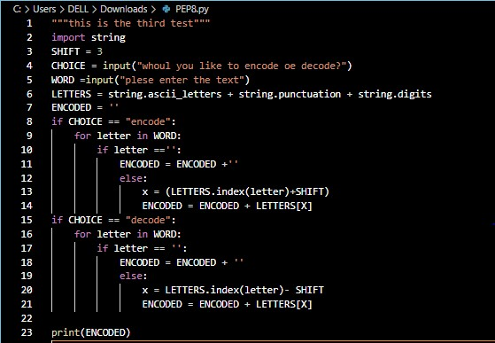

2